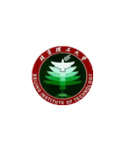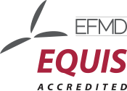Beijing Institute of Technology School of Management and Economics

**2019 Beijing Institute of Technology Management Enterprise Finance Summit**

**Organizer: the School of Management and Economics**

**Hosts: Alumni Office, Alumni Finance Club, MBA Federation**

**Time: Saturday, November 16,2019. 16:00.**

**Location: 133 of the Main Building on Zhongguancun Campus, Beijing University of Technology**

**Topic: "Bank and the Enterprise, Co-operation and Mutual Development"**

|  |  |
| --- | --- |
| Time | Main Contents |
| 14:00-14：05 | School promotional film |
| 14:05-14:10 | Speech by the School leader |
| 14:10-14:20 | Book donation ceremony |
| 14:20  -  16:20 | Yang Wenpu: The Current International and Domestic Economic Situation and the Change of Financial Market |
| Gao Yu: Practicing the Great University Motto, Harvesting Wealth and Health |
| Wang Hao: Enterprise Value Management-- Conservative and Unusual |