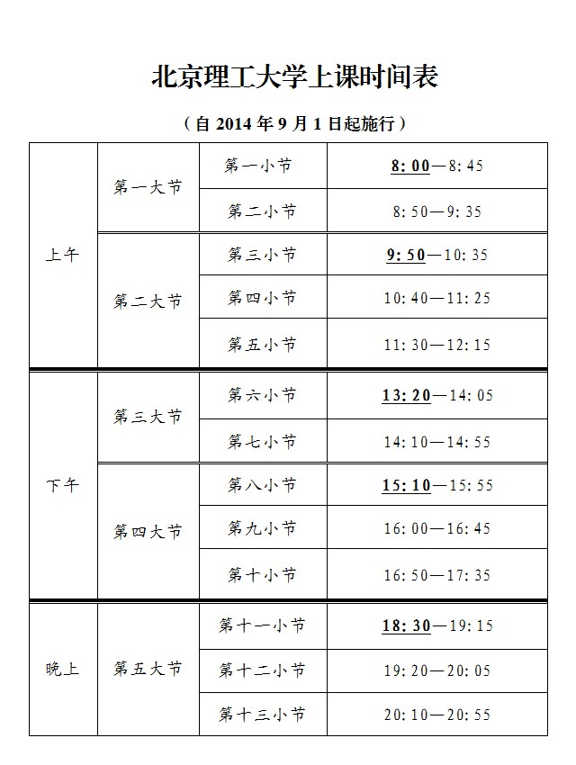

[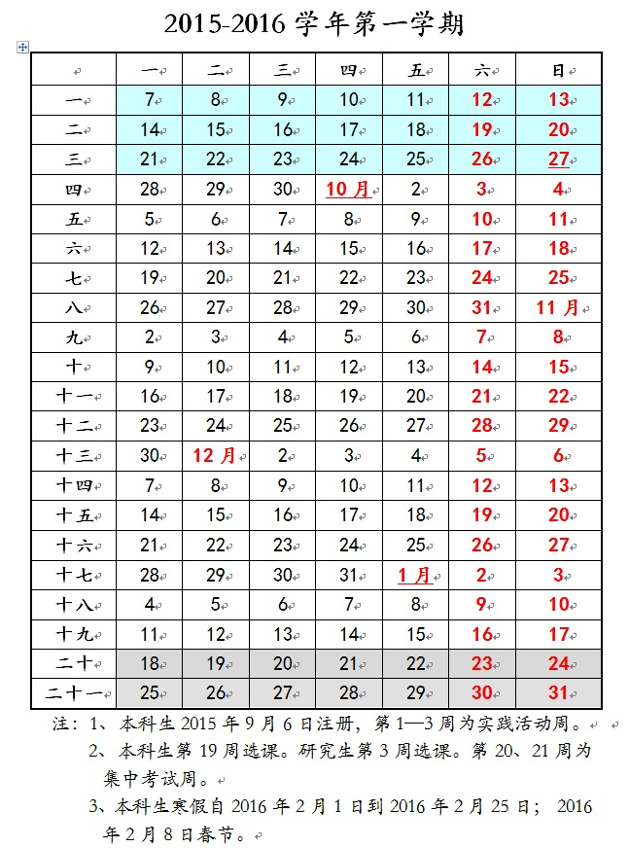](http://jwc.bit.edu.cn/upimg/allimg/1506/13_25103008.jpg)

[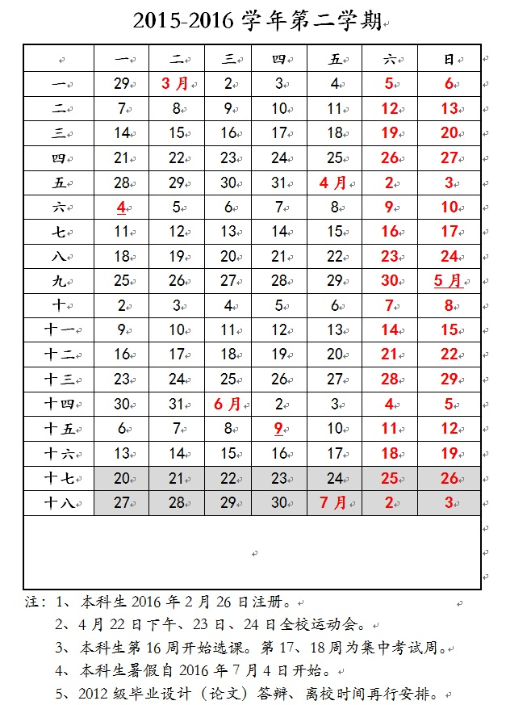](http://jwc.bit.edu.cn/upimg/allimg/1506/13_25103242.jpg)